[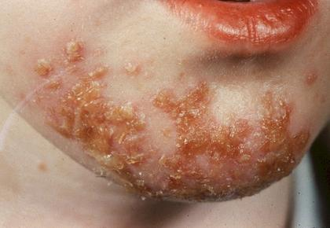](http://www.google.nl/url?sa=i&rct=j&q=impetigo&source=images&cd=&cad=rja&docid=uhXUVOuWfrD6ZM&tbnid=fph0pH01ZrQQvM:&ved=0CAUQjRw&url=http://turpinanatomy1.wikispaces.com/impetigo&ei=Pa1vUbSAGOjK0QWJsYGADQ&bvm=bv.45368065,d.d2k&psig=AFQjCNG0Uzy_ryIMMFvBVpr5qleKVY_oCA&ust=1366359559595345)

**Impetigo = krentenbaard**